Harvey High School
To Wisdom We Climb

Grade 9 HOME LEARNING PLAN

TEACHER | Email | Homeroom | Grade/subjects taught
Mr. D. Fletcher | Don.fletcher@nbed.nb.ca |  | Math 9EFI
Mrs. Henry | Ara.henry@nbed.nb.ca |  | 9E Social Studies
Mrs. Miller | Andrea.miller@nbed.nb.ca |  | 9E PIF, 9 FI PE
Mrs. Dufresne | Pamela.Linton-Dufresne@nbed.nb.ca |  | English 9
Mr. White | David.white@nbed.nb.ca | 9A | 9 FI Social Studies
Mr. Woodworth | Kyle.woodworth@nbed.nb.ca |  | Science 9
Mrs. Arsenault | catherine.arsenault@nbed.nb.ca | 9B
Ms. Crawford | Catherine.crawford@nbed.nb.ca
Mme. Noble | Tina.noble@nbed.nb.ca |  | VP
Ms. Parra | Julia.parra@nbed.nb.ca |  | Resource
Mrs. Drummond | Cynthia.drummond@nbed.nb.ca |  | MS Resource
Ms. Collicott | Crysta.collicott@nbed.nb.ca |  | Principal
School Email | harveyhigh@nbed.nb.ca

WEEKLY PLAN – April
Subject
Literacy | English 9 –  Learning Opportunity – Describe a Process  Time: Up to 30 minutes/Day until complete  Task: Create an instruction manual that outlines a step-by-step process that you have accomplished recently. You could look at a car owner’s manual, or Lego instructions as an example.  Reflection: What pictures/diagrams would I use?  Pretend your audience has never seen what you have; be clear and descriptive.  Remember to be including reading in your daily lives.  Online Resources:  https://ca.ixl.com/ - work on what you think will help you with your writing.  New Brunswick Public Libraries offer many learning experiences and free access to downloadable ebooks. To access this site, you will need your library card number. If you don’t have one, get one online https://www2.gnb.ca/content/gnb/en/departments/nbpl.html  French 9: For Written or Oral French Activities, check your nbed email account and the Microsoft Teams app on Office 365.
Numeracy | Math 9  Please see summary on Mr. D. Fletcher’s page on the HHS website.  Click here for link  Online Resources:  Khan Academy offers math instruction for all levels of learners, organized by both subject and grade. https://www.khanacademy.org/math  https://www.aaamath.com/  https://ca.ixl.com/  https://ttrockstars.com/
Science | There is a checklist on Mr. Woodworth’s teacher page of the HHS website with work that can be completed this week. Click here to go to the teacher page.  Online Resources:  Explore the Earth from Home is a collection of resources to explore weather, climate, air quality, and other earth science topics. https://scied.ucar.edu/help-k-12-students-learn-about-earth-home
Social Studies | https://www.youtube.com/watch?v=7C8uDuhLqvg (English)  https://www.youtube.com/watch?v=-xVo8ZNUTjA&feature=youtu.be (French)  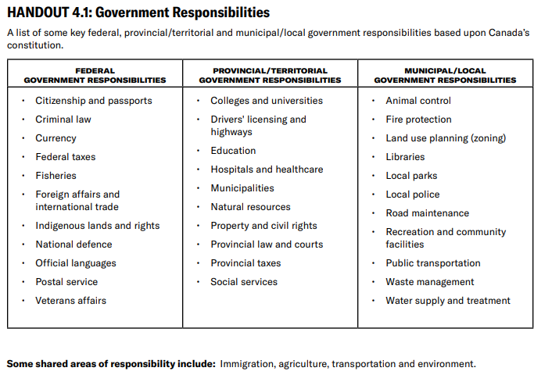  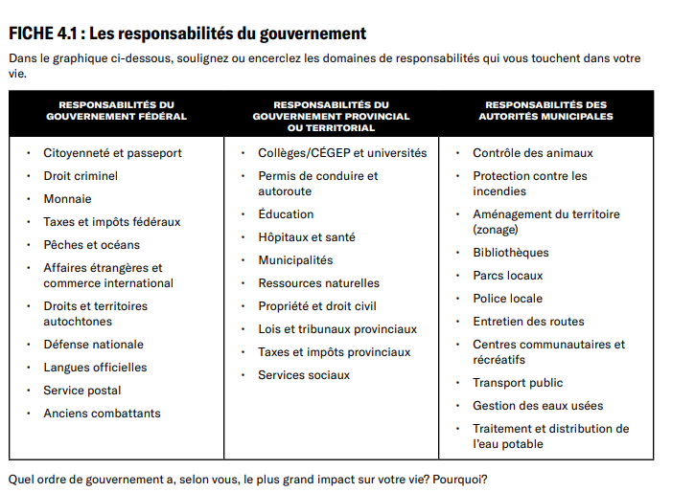  Handout 4.1: Government Responsibilities. Student Vote Classroom Resources: Secondary Level. CIVIX by Elections Canada. 2019. https://studentvote.ca/canada/classroom-resources/  After watching the video and reading the chart, complete the following.  Determine which level of government would deal with some one who…..  - Wishes to join the military  - Has a concern about the elementary or secondary curriculum  - Has a concern about drinking water  - Wants to know if a medical procedure is covered by medicare  - Has an inquiry about employment insurance  - Has a property line dispute  - Want to know when garbage is collected  - Wants to inquire about a relative moving to Canada  - Has a question about income tax  Fitton, Avis et al. Canadian Identity. Nelson – Thompson Canada. 2006. Toronto, Ontario, Canada. 230.  Extension: search Canadian news websites for news events happening in the last 6 months. Identify the issue and which level of government should be involved.  Going one more step: How might this division of powers be temporarily impacted due to emergency measures?  Online Resources:  Newsela provides students with thousands of texts on topics they care about most. https://newsela.com/
Life Skills | This week cook a meal for your family. You can pick a recipe of your own, or you can follow this simple recipe to help out your parents and learn some cooking skills. If you have never cooked before, you may want to ask a parent to help you the first time to make sure you do it safely.  Pasta with Fresh Tomato Sauce  Ingredients: You can substitute a canned or bottled sauce if you do not have the ingredients at home. Just heat on low in a saucepan. Also, if you like, you can add browned ground beef.  - 2 lbs tomatoes  - ¼ cup basil leaves  - 1 tablespoon parsley  - 2 chopped garlic cloves  - ¼ cup olive oil  - Salt and pepper  - 1 box of spaghetti or spaghettini  - Grated parmesan cheese (optional)  Instructions:  - Finely chop tomatoes, basil, parsley, and garlic, and mix together with oil (or pulse ingredients, including oil, in a food processor to blend).  - Bring a large pot of salted water to a boil. Add pasta, and cook according to the package instructions. Drain pasta, and toss it in a serving bowl with the raw sauce. Transfer to 6 shallow bowls, and drizzle with oil. Serve with cheese.
Phys. Ed. | It is recommended that you complete 30 minutes of physical activity a day.  Training your balance. Why do it? Training your balance can help prevent falls, prevent injuries, and help you to understand how to control your body better when moving.  Ways to train balance:  - Yoga  - Tai Chi  - Walking on a balance beam (you can create one of your own, just make sure it is low to the ground)  - Standing on one foot, then extending the other foot to the front, back or side.  - Walking heel to toe.  Try to train balance at least one day this week. Spend your other days working on cardiorespiratory endurance, strength and agility. Look into the previous learning plans for ideas on how to do those activities. Remember to stay safe when exercising, and most of all, to have fun!

Offline activities
https://www2.gnb.ca/content/dam/gnb/Departments/ed/pdf/promo/learning_at_home/QuickStart_OfflineActivities_High.pdf

Online resources
https://www2.gnb.ca/content/dam/gnb/Departments/ed/pdf/promo/learning_at_home/QuickStart_OnlineResources_High.pdf

